**User**

Add User in Linux

Sudo adduser username

Delete User

Sudo userdel username

/etc/passwd have all the user details to view them

Sudo vim /etc/passwd

Change password

Sudo passwd username (It will prompt to change the password)

**Groups**

Add group

Sudo groupadd groupname (eg: sudo groupadd marketing)

Delete group

Sudo groupdel groupname

Add users to the group

Sudo adduser username groupname (eg: sudo adduser sanka marketing)

Delete user from the groupname

Sudo deluser username groupname

Group information saved

Sudo vim /etc/group

**Permission**

777 in here

First digit is the permission of the owner of the file permission

Second digit is member of the group of the file permission

Third digit is everybody else permission

7 = all permission (Read, Write, Execute)

4 = read permission only

2 = write permission only

1 = execute permission

Change permission

Sudo chmod 777 file/foldername

Sudo chmod foldername –R (-R = is recursive so it goes to every folders underneath)

**Ownership of File or Folder**

Change ownership

Sudo chown file/folder

Sudo chown –R foldername (if it is a folder so that the recursive folders get the same)

Change group permission

Sudo chgrp groupname file/folder

Sudo chgrp -R groupname file/folder (if it is a folder so that the recursive folders get the same)

**Links**

Create a soft link



Create a softlink name myShortcut to the test.txt file

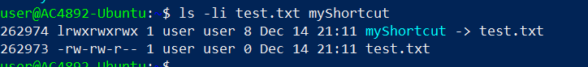

To view that use the mentioned command

At first line it shows that myShortcut is link to test.txt file and since its address is different these are two files

Create a hardlink



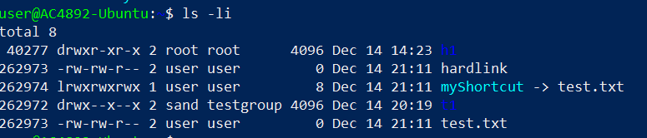

As we can see that the hadlink and the test.txt have the same address since these are same file

Backup

Sudo tar -cvpzf filename.tar.gz

-c = create the backupfile

v = linux kernel says what is going on (eg: copying this file, copying this directory)

p = preserving permission (backup the file permissions as well)

z = compression (once the backup set compress it more to be small as possible)

f = give a name to the backup file

Exclude the files or folders

Sudo tar -cvpzf filename.tar.gz --exclude = /directoryname /backupfoldername

(eg: Sudo tar -cvpzf filename.tar.gz --exclude = /mnt /) 🡪 / means backup from root

Recover from tar file

Sudo tar –xvpzf filename.tar.gz –C /recoverdirectorypath

x =extract

v = verbose to show what’s happening

p = preserve permissions

z = un compressed

f = give filename

C = change tar to uncompressed to another directory

Schedule

*** Sudo crontab -e

*** m h dom m dow comm

0 – 59 (mins) 0-23(hour) 1-31(DateofMonth) 1-12(month) 0-6(Sunday 0) command

Eg: 2.30 in the morning every Tuesday

30 2 * * 2

e = edit the crontab



/var/www/wp-content 🡪 get the files in this directory

Delete the file

*** Sudo crontab -e

Then delete the line

**VIM Editor**

Vim filename.txt

i = to insert mode

if we are done editing it press ‘esc’ then

:wq 🡪 write and quit

:q! 🡪 quit without modifying it

:q 🡪 quit